AUTOMATIC INDUSTRIAL SAFETY AND SECURITY SYSTEM
Prashant S. Suryawanshi, Kaustubh A. Dighe, Abhijit B. Deshmukh
Prof. Rathod G. G (Project Guide)
Department of E&TC Diploma Engineering, Amrutvahini Polytechnic, Sangamner, India

Abstract
Nowadays technology is advancing rapidly, driving major upgrades in industrial security systems. Automation in the security sector makes monitoring more reliable and authentic. Many pieces of electrical equipment in an industry need to be monitored remotely and simultaneously. This project proposes a smart industrial control and safety system that combines multiple sensors with a GSM-based alerting technique. A stand-alone system built on the Internet of Things (IoT) is implemented as the communication backbone, with an ARM7 (LPC2148) microcontroller, programmed in embedded C, acting as the central controller.

Keywords
Automation; Safety; Security; Sensors; IoT; ARM7; GSM.

1. Introduction
Ensuring safety and smartness in industrial environments has become essential. As modern technology advances, the security systems used in industries are also evolving rapidly. A modern industry that operates with minimal human intervention is referred to as a smart industry. With the advent of wireless and digital technology, it becomes possible to build an automated, intelligent security and monitoring system. The automatic industrial safety and security system described here is built around multiple sensors working together with a central microcontroller.

1.1 Literature Review
This project presents the specification, design and implementation of an industrial automation system that is flexible, generally programmable, and extensible, so that additional features can be added without redesigning the entire system. To achieve this, the system runs a fixed embedded-C program on a special-purpose microcontroller, using real-world sensor inputs as operands. The sensors and other input mechanisms, together with user-programmable thresholds, allow the environment to be adjusted and customized automatically. By using sensors that measure temperature, light level, gas concentration, flame, alcohol vapor, and motion, the system creates a safe, comfortable, and smart industrial atmosphere.

1.2 IoT Service
The concepts of the Internet of Things (IoT) are applied across many domains, ranging from home automation to industrial IoT, where physical devices are connected from anywhere through a network. Devices become active participants on the network, exchanging information about themselves and their surroundings. This gives immediate access to information about the physical world, leading to innovative services and increased efficiency and productivity.

1.3 Block Diagram
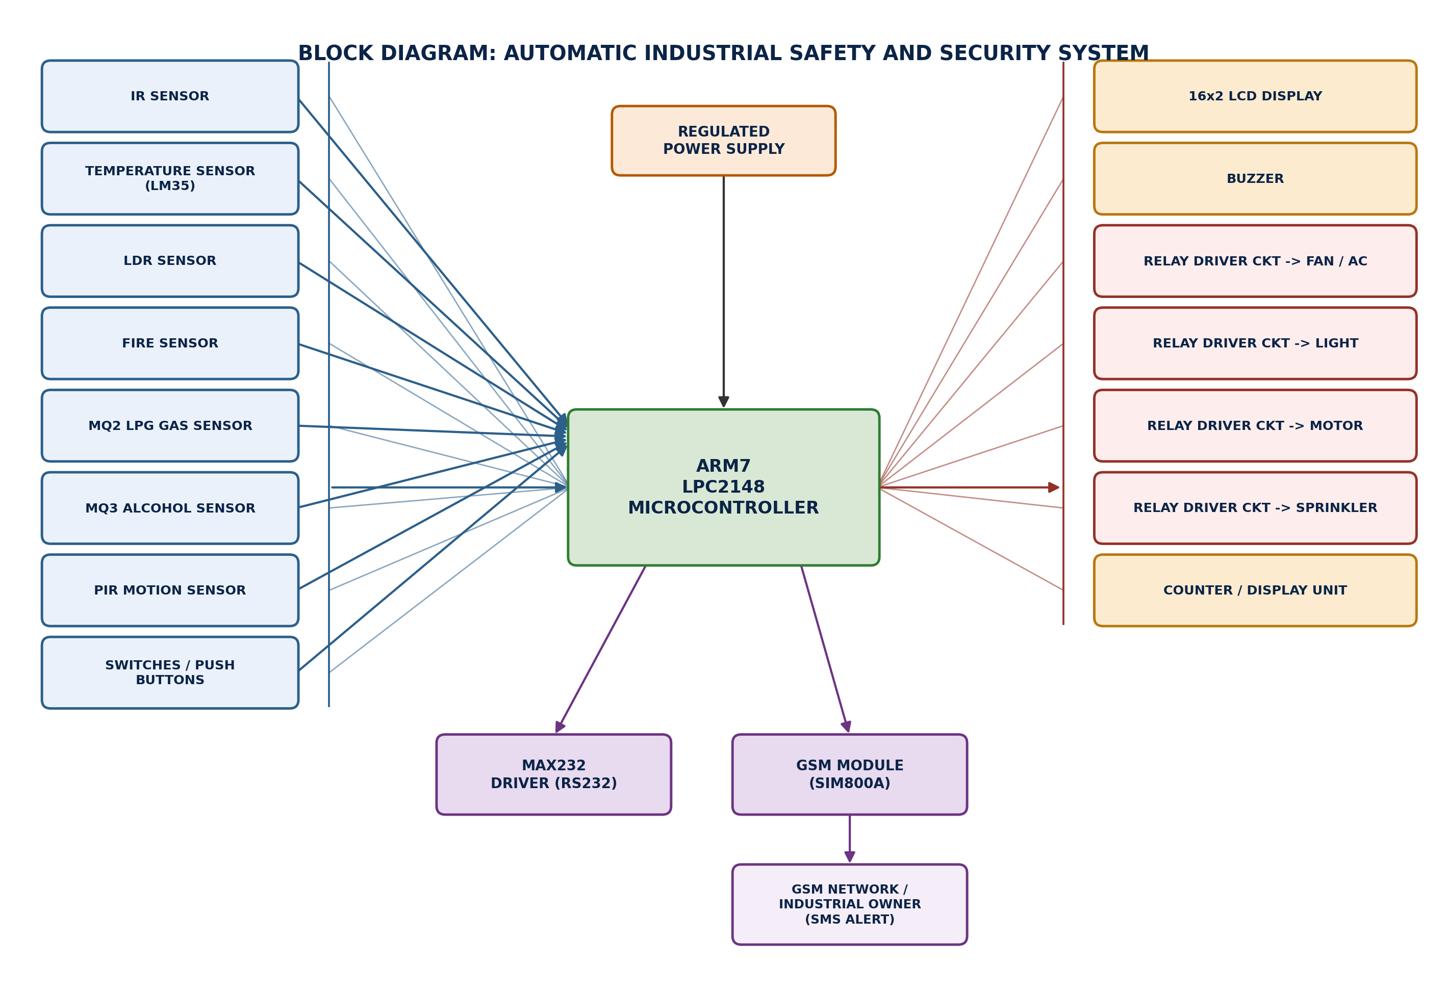
Fig. 1 — Block diagram of the Automatic Industrial Safety and Security System

1.4 Hardware / Component Requirement with Specification

I. Controller — ARM LPC2148
ARM (Advanced RISC Machine) is a 32-bit RISC (Reduced Instruction Set Computer) processor architecture developed by ARM Holdings. ARM is an architecture used across many processors and microcontrollers; the LPC2148 is an ARM7TDMI-S based microcontroller from NXP with on-chip Flash, ADC, UART, timers and GPIO, making it well suited to this kind of embedded control application.

II. GSM Module — SIM800A
The GSM modem used is based on the SIM800A chip with an RS232 interface, allowing easy connection to a computer/laptop through a USB-to-Serial connector, or to the microcontroller through an RS232-to-TTL converter. The module communicates at a default baud rate of 9600 and is controlled using standard AT commands, which the microcontroller uses to send SMS alerts to the industrial owner.

III. IR Sensor
An IR sensor basically consists of an IR LED and a photodiode, together called an IR pair or photocoupler. It works on the principle that the IR LED emits infrared radiation and the photodiode senses the reflected radiation, allowing detection of nearby objects or intrusions.

IV. PIR Sensor
PIR (Passive Infrared) sensors are somewhat more complex than sensors like photocells or tilt switches because multiple variables affect their input and output. They detect motion by sensing changes in infrared radiation emitted by warm bodies moving within their field of view.

V. Alcohol Sensor — MQ3
An alcohol sensor detects the concentration of alcohol vapor in the air and produces an analog voltage as its output. The sensor operates over a temperature range of approximately -10°C to 50°C with a supply current under 150 mA at 5 V. Its sensing range is roughly 0.04 mg/L to 4 mg/L, which makes it suitable for breathalyzer-style detection near industrial machinery.

VI. MQ2 LPG Gas Sensor
The MQ2 gas sensor module is useful for gas leakage detection in both home and industrial settings. It is suitable for detecting H2, LPG, CH4, CO, alcohol, smoke, and propane. Because of its high sensitivity and fast response time, a leak can be measured and flagged almost as soon as it occurs.

1.6 Tools Used
Development and deployment of this project relies on the following tools:
- Keil µVision (ARM-MDK) — the IDE and ARM compiler/linker used to write, build, and debug the embedded-C source for the LPC2148; it also includes a built-in software simulator for testing GPIO/ADC logic before touching hardware.
- Flash Magic — a free ISP (In-System Programming) utility used to load the compiled .hex file onto the LPC2148 over its UART0 bootloader, after the board is put into ISP mode.
- Proteus / a JTAG debugger (optional) — Proteus can be used for schematic capture and pre-hardware simulation; a JTAG adapter (e.g. ULINK, J-Link) allows direct Download/Debug from Keil if the board exposes a JTAG header, as an alternative to Flash Magic.
- PuTTY / any serial terminal — used on a PC to manually test the SIM800A module's AT-command responses over USB-to-RS232 before it is driven by the microcontroller.
- Multimeter / logic probe — for verifying supply rails, relay switching, and sensor output levels during hardware bring-up.
- Soldering iron, breadboard/PCB, jumper wires, 5 V/12 V regulated power supply — for physical assembly of the sensor, relay, and driver stages around the LPC2148 board.

1.7 Flow of Execution
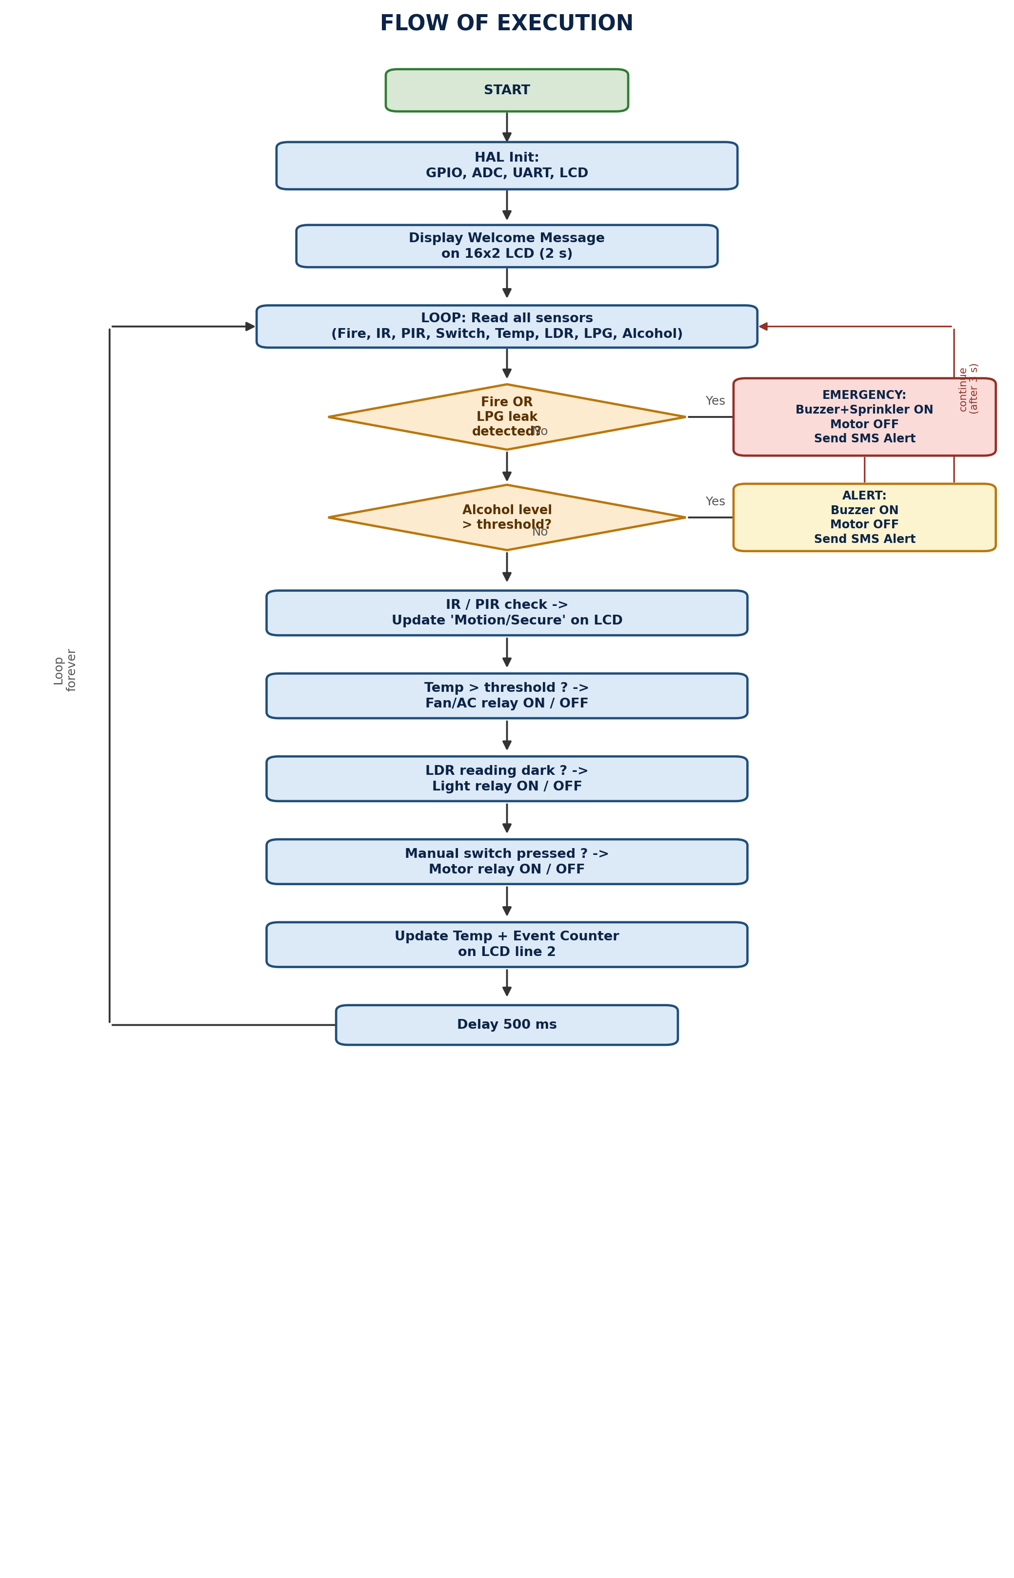
Fig. 2 — Flow of execution of the main control loop
After HAL peripheral initialization and a 2-second welcome message, the firmware enters an infinite loop. On every pass it reads all sensors first, then checks conditions strictly in priority order: fire or LPG leak (highest priority — triggers the sprinkler and an SMS, then the loop restarts immediately), alcohol detection (stops the motor and sends an SMS), and only if neither emergency is active does it fall through to routine automation — motion display, temperature-based fan control, LDR-based lighting, and the manual motor switch — before updating the LCD status line and repeating after a 500 ms delay.

1.8 Component-Wise Explanation
The illustrations below are original schematic icons (not manufacturer photographs) representing the role and connection style of each module in the system.
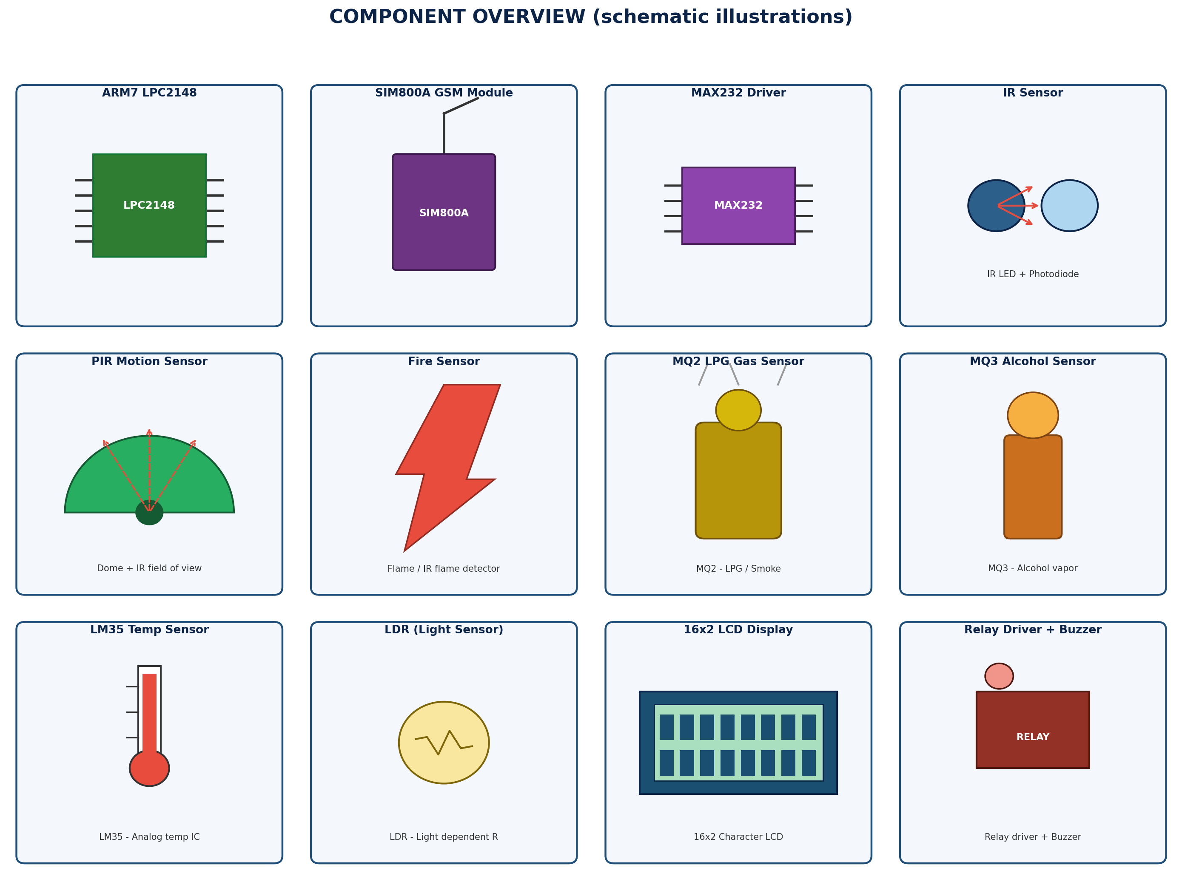
Fig. 3 — Component overview

1.8.1 ARM7 LPC2148 (Controller)
The central processing unit of the system. A 32-bit ARM7TDMI-S core from NXP with on-chip Flash, two ADC blocks, multiple UARTs, timers, and 45 GPIO lines. It runs the HAL-layer firmware, polls every sensor, makes the safety decisions, and drives every output in the system.

1.8.2 SIM800A GSM Module
A quad-band GSM/GPRS modem controlled with AT commands over a serial (RS232/TTL) link at 9600 baud. In this project it is driven by UART1 of the LPC2148 (via the HAL_UART driver) to send SMS alerts to the industrial owner whenever a fire, gas leak, or alcohol-intrusion event occurs.

1.8.3 MAX232 Level Shifter
Converts the LPC2148's 3.3 V/5 V TTL UART signals to the +/-12 V RS232 levels (and back) required by serial-port style GSM modules and PC terminal connections, protecting the microcontroller's UART pins.

1.8.4 IR Sensor
Consists of an IR LED and a photodiode (an IR pair). The LED continuously emits infrared light; the photodiode's conduction changes when that light is reflected back by a nearby object, giving a simple digital presence/intrusion signal read on P0.6.

1.8.5 PIR Motion Sensor
Detects motion by sensing changes in the infrared radiation naturally emitted by warm bodies moving through its dome-shaped field of view. Its digital output (P0.7) toggles when movement is detected, complementing the IR sensor for intrusion detection.

1.8.6 Fire Sensor
An IR-flame-sensitive module that outputs a digital HIGH when it detects the specific infrared wavelength band emitted by open flame. Wired to P0.8, it is treated as the highest-priority safety input in the firmware.

1.8.7 MQ2 LPG / Gas Sensor
A metal-oxide semiconductor gas sensor whose resistance drops in the presence of LPG, methane, CO, smoke, or propane. Its analog output is read on ADC channel 2 (AD0.2); crossing a calibrated threshold is treated as a gas-leak emergency.

1.8.8 MQ3 Alcohol Sensor
Similar metal-oxide technology tuned for alcohol vapor, operating over roughly -10°C to 50°C with a sensing range of about 0.04-4 mg/L. Read on ADC channel 3 (AD0.3), it is used to detect an intoxicated person near the machine and halt the motor for safety.

1.8.9 LM35 Temperature Sensor
A precision analog IC that outputs a voltage linearly proportional to temperature in °C. Read on ADC channel 0 (AD0.0), its value drives automatic fan/AC switching once the industrial floor temperature crosses the configured set point.

1.8.10 LDR (Light Dependent Resistor)
A photoresistor whose resistance falls as ambient light increases. Read (through a divider) on ADC channel 1 (AD0.1), it lets the firmware switch industrial lighting on automatically once it gets dark — replacing energy-hungry HID lamps with power-conserving, sensor-driven LED lighting.

1.8.11 16x2 LCD Display
A character LCD driven in 4-bit mode over six GPIO lines (RS, EN, D4-D7). It displays the welcome message at boot and, during normal operation, the live intrusion/secure status, temperature reading, and event counter, plus emergency messages when triggered.

1.8.12 Relay Driver Stages + Buzzer
Each relay driver stage (typically a transistor/ULN2003-style driver plus a relay) lets the low-current GPIO outputs (P0.17-P0.20) safely switch mains-level loads: the fan/AC, lighting, motor, and sprinkler pump. The buzzer (P0.16) provides an immediate on-site audible alert for fire, gas, or alcohol events.

1.9 Step-by-Step Project Build Process
- Step 1 - Requirement analysis: identify the hazards to monitor (fire, gas, alcohol, intrusion) and the loads to control (fan, light, motor, sprinkler).
- Step 2 - Circuit design: finalize the pin map for the LPC2148 (given in the code header), and design/simulate the sensor and relay-driver stages, e.g. in Proteus, before building physically.
- Step 3 - Component procurement and hardware assembly: mount the LPC2148 board, sensors (IR, PIR, fire, MQ2, MQ3, LM35, LDR), 16x2 LCD, relay driver modules, buzzer, MAX232, and SIM800A GSM module on a breadboard or PCB, wiring each to the pins specified in the source file.
- Step 4 - Power-up and continuity check: verify the regulated 5 V/3.3 V supply rails and confirm every module powers up correctly with a multimeter before connecting to the microcontroller.
- Step 5 - Firmware development: write the HAL driver layer (GPIO/ADC/UART) and the application logic in Keil µVision, as provided in Section 1.11 below.
- Step 6 - Compile: build the project in Keil (Project -> Build Target) to produce the .hex output, resolving any compiler warnings first.
- Step 7 - Flash the firmware: put the LPC2148 into ISP mode and use Flash Magic (or a JTAG debugger's Download command in Keil) to program the .hex file onto the chip.
- Step 8 - Subsystem testing: test each peripheral in isolation - LCD welcome message, each sensor's raw ADC/digital reading printed to the LCD, each relay toggling its load, and the GSM module responding to AT commands from a serial terminal.
- Step 9 - Integration testing: run the complete loop and verify the priority logic - trigger the fire/gas condition and confirm sprinkler + SMS, trigger alcohol detection and confirm motor cut-off + SMS, then confirm routine fan/light/motor automation resumes correctly afterward.
- Step 10 - Calibration: tune the threshold constants (TEMP_HIGH_THRESHOLD, LDR_DARK_THRESHOLD, LPG_GAS_THRESHOLD, ALCOHOL_THRESHOLD) against the actual sensor readings taken from your hardware.
- Step 11 - Enclosure and deployment: mount the finished board and wiring in a protective enclosure near the monitored area, with sensors positioned for correct exposure (fire/gas sensors near likely leak points, PIR/IR covering the entry path, LDR facing ambient light).
- Step 12 - Final validation and handover: run a full end-to-end test on-site, confirm the industrial owner receives SMS alerts on the configured mobile number, and document the deployment.

1.10 Working Principle of the Project
The ARM LPC2148 microcontroller is the controller for this project, with the system clock playing a significant role in its operation. Temperature is sensed using the LM35 IC. The project controls various industrial appliances that are conventionally switched using manual effort. Traditionally, industrial lighting has used HID lamps, which consume a large amount of energy and have no automatic mechanism to switch off from sunrise to sunset. To address this, the project uses LEDs together with an LDR sensor for intensity-controlled, power-conserving industrial lighting.
The temperature sensor converts the sensed temperature into an equivalent electrical value. When the industrial temperature rises above a configured set point, the fan is switched on automatically; when it drops back below the set point, the fan is switched off automatically. The gas sensors are used in industrial areas to continuously monitor for hazardous gases and vapors, generating audible and visual alarms whenever a leak is detected, so personnel can be alerted quickly. The MQ3 alcohol sensor has high sensitivity and is used for personnel safety — if a person under the influence of alcohol is detected near the machine, the system activates an alert and disables the motor, i.e. "motor turn off" is used to mean "machine turn off". The fire sensor is used to detect flame; if fire is detected and spreading, the system raises an alarm and automatically activates the sprinkler relay. IoT is used to push all indication data — percentages and status — to a remote server, and the GSM module notifies the industrial owner by SMS. A 16x2 LCD display shows the live sensor parameters and system status on-site.

1.11 Brief Explanation of the Project
The Automatic Industrial Safety and Security System is a standalone embedded monitoring and control unit built around the ARM7 LPC2148 microcontroller. It continuously reads eight sensor inputs — an IR sensor and a PIR sensor for intrusion/motion detection, a fire sensor, an MQ2 sensor for LPG/combustible gas leakage, an MQ3 sensor for alcohol vapor, an LM35 temperature sensor, an LDR for ambient light level, and a manual override switch — and uses that data to automatically drive four relay-controlled loads (a fan/AC, lighting, a motor, and a sprinkler), a buzzer, and a 16x2 LCD status display.
The control logic follows a clear priority order: a fire condition or a detected LPG leak is treated as the highest-priority emergency, immediately sounding the buzzer, switching off the motor, activating the sprinkler relay, and sending an SMS alert to the industrial owner through the SIM800A GSM module. Alcohol detection near the machine is treated as a personnel-safety condition and stops the motor ("motor off" is used to mean "machine off") while alerting the owner by SMS. In the absence of these emergencies, the system runs routine automation: the fan/AC is switched on once the temperature crosses a configured threshold, the lighting relay is switched on automatically once the LDR reading indicates darkness (replacing energy-hungry HID lamps with a power-conserving LED + LDR arrangement), and IR/PIR activity is reported live on the LCD together with an internal event counter. All of this runs as a single continuous polling loop, with the GSM link providing the IoT-style remote notification the original paper describes.
Architecturally, the code is organized as a HAL (Hardware Abstraction Layer): a driver layer (HAL_GPIO_*, HAL_ADC_*, HAL_UART_*, HAL_Delay, plus LCD_* and GSM_* helper modules built on top of it) wraps the LPC2148's registers, and the application logic in main() calls only these HAL functions rather than touching registers like IOSET0, AD0CR, or U1THR directly. This keeps the safety logic readable and portable, mirroring the structure of vendor HAL libraries while still targeting the ARM7 LPC2148 named in the original paper.

1.12 Complete HAL-Method Embedded C Source Code (ARM7 LPC2148)
The program below is organized as a Hardware Abstraction Layer running on the ARM7 LPC2148: Section 1-7 implement HAL_GPIO, HAL_Delay, HAL_ADC, HAL_UART, an LCD driver, and a GSM/SMS driver, each built directly on top of the LPC2148 registers; Section 8-9 implement the application (pin map, safety-event handlers, and main()) using only the HAL-layer API.
/*==========================================================================
PROJECT : AUTOMATIC INDUSTRIAL SAFETY AND SECURITY SYSTEM
MCU : ARM7 - LPC2148 (NXP/Philips)
STYLE : HAL (Hardware Abstraction Layer) method
A thin, STM32-HAL-style driver layer (HAL_GPIO_xxx,
HAL_ADC_xxx, HAL_UART_xxx, HAL_Delay) is built directly on
top of the LPC2148 registers. The application logic in
main() calls ONLY these HAL functions and never touches
IOSET0/IOCLR0/AD0CR/U1THR etc. directly — this gives the
same portability/readability benefits as vendor HAL
libraries while still running on the ARM7 LPC2148.
============================================================================*/

#include <LPC214x.h>

/*==========================================================================
SECTION 1 : HAL TYPE DEFINITIONS
==========================================================================*/
typedef enum { HAL_PIN_RESET = 0, HAL_PIN_SET = 1 } HAL_PinState;
typedef enum { HAL_MODE_INPUT = 0, HAL_MODE_OUTPUT = 1 } HAL_PinMode;
typedef enum { HAL_OK = 0, HAL_ERROR = 1, HAL_BUSY = 2, HAL_TIMEOUT = 3 } HAL_StatusTypeDef;

/*==========================================================================
SECTION 2 : HAL_GPIO DRIVER (Port 0 only, extendable to Port 1)
==========================================================================*/
void HAL_GPIO_Init(unsigned long pinMask, HAL_PinMode mode)
{
if (mode == HAL_MODE_OUTPUT)
IODIR0 |= pinMask;
else
IODIR0 &= ~pinMask;
}

void HAL_GPIO_WritePin(unsigned long pinMask, HAL_PinState state)
{
if (state == HAL_PIN_SET)
IOSET0 = pinMask;
else
IOCLR0 = pinMask;
}

HAL_PinState HAL_GPIO_ReadPin(unsigned long pinMask)
{
return (IOPIN0 & pinMask) ? HAL_PIN_SET : HAL_PIN_RESET;
}

/*==========================================================================
SECTION 3 : HAL_DELAY (SysTick-less busy-wait, tuned for ~60 MHz PCLK)
==========================================================================*/
void HAL_Delay(unsigned int ms)
{
unsigned int i, j;
for (i = 0; i < ms; i++)
for (j = 0; j < 6000; j++)
;
}

/*==========================================================================
SECTION 4 : HAL_ADC DRIVER (AD0, 10-bit)
==========================================================================*/
void HAL_ADC_Init(void)
{
/* Enable AD0.0 - AD0.3 pin functions (PINSEL1 alt-function bits) */
PINSEL1 |= (1 << 24) | (1 << 26) | (1 << 28) | (1 << 30);
}

unsigned int HAL_ADC_Read(unsigned char channel)
{
unsigned int value;

AD0CR = (1 << channel) | (4 << 8) | (1 << 21) | (1 << 24);

while (!(AD0DR(channel) & 0x80000000UL))
; /* poll DONE bit */

value = (AD0DR(channel) >> 6) & 0x3FF;
return value;
}

/*==========================================================================
SECTION 5 : HAL_UART DRIVER (UART1 -> GSM SIM800A)
==========================================================================*/
HAL_StatusTypeDef HAL_UART_Init(unsigned int baud)
{
unsigned int divisor = 15000000UL / (16UL * baud); /* PCLK = 15 MHz example */

PINSEL1 |= (1 << 30) | (1 << 28); /* route TxD1/RxD1 (board-dependent) */
U1LCR = 0x83; /* 8N1, DLAB = 1 */
U1DLL = (unsigned char)(divisor & 0xFF);
U1DLM = (unsigned char)((divisor >> 8) & 0xFF);
U1LCR = 0x03; /* DLAB = 0 */
return HAL_OK;
}

HAL_StatusTypeDef HAL_UART_Transmit(const unsigned char *data, unsigned int len, unsigned int timeout_ms)
{
unsigned int i, waited;
for (i = 0; i < len; i++)
{
waited = 0;
while (!(U1LSR & 0x20))
{
HAL_Delay(1);
if (++waited > timeout_ms)
return HAL_TIMEOUT;
}
U1THR = data[i];
}
return HAL_OK;
}

HAL_StatusTypeDef HAL_UART_TransmitString(const char *str, unsigned int timeout_ms)
{
unsigned int len = 0;
const char *p = str;
while (*p++) len++;
return HAL_UART_Transmit((const unsigned char *)str, len, timeout_ms);
}

/*==========================================================================
SECTION 6 : LCD DRIVER — built on HAL_GPIO (16x2, 4-bit mode)
==========================================================================*/
#define LCD_RS (1UL<<0)
#define LCD_EN (1UL<<1)
#define LCD_D4 (1UL<<2)
#define LCD_D5 (1UL<<3)
#define LCD_D6 (1UL<<4)
#define LCD_D7 (1UL<<5)
#define LCD_DATA_MASK (LCD_D4|LCD_D5|LCD_D6|LCD_D7)

static void LCD_PulseEnable(void)
{
HAL_GPIO_WritePin(LCD_EN, HAL_PIN_SET);
HAL_Delay(1);
HAL_GPIO_WritePin(LCD_EN, HAL_PIN_RESET);
HAL_Delay(1);
}

static void LCD_WriteNibble(unsigned char nibble, unsigned char isData)
{
HAL_GPIO_WritePin(LCD_RS, isData ? HAL_PIN_SET : HAL_PIN_RESET);

HAL_GPIO_WritePin(LCD_D4, (nibble & 0x01) ? HAL_PIN_SET : HAL_PIN_RESET);
HAL_GPIO_WritePin(LCD_D5, (nibble & 0x02) ? HAL_PIN_SET : HAL_PIN_RESET);
HAL_GPIO_WritePin(LCD_D6, (nibble & 0x04) ? HAL_PIN_SET : HAL_PIN_RESET);
HAL_GPIO_WritePin(LCD_D7, (nibble & 0x08) ? HAL_PIN_SET : HAL_PIN_RESET);

LCD_PulseEnable();
}

void LCD_Cmd(unsigned char cmd)
{
LCD_WriteNibble(cmd >> 4, 0);
LCD_WriteNibble(cmd & 0x0F, 0);
if (cmd == 0x01 || cmd == 0x02) HAL_Delay(2);
}

void LCD_Data(unsigned char data)
{
LCD_WriteNibble(data >> 4, 1);
LCD_WriteNibble(data & 0x0F, 1);
}

void LCD_String(const char *str)
{
while (*str) LCD_Data((unsigned char)*str++);
}

void LCD_SetCursor(unsigned char row, unsigned char col)
{
LCD_Cmd((row == 0 ? 0x80 : 0xC0) + col);
}

void LCD_Init(void)
{
HAL_GPIO_Init(LCD_RS | LCD_EN | LCD_DATA_MASK, HAL_MODE_OUTPUT);

HAL_Delay(20);
LCD_WriteNibble(0x03, 0); HAL_Delay(5);
LCD_WriteNibble(0x03, 0); HAL_Delay(1);
LCD_WriteNibble(0x03, 0);
LCD_WriteNibble(0x02, 0); /* 4-bit mode */

LCD_Cmd(0x28); /* 4-bit, 2 line, 5x8 font */
LCD_Cmd(0x0C); /* display ON, cursor OFF */
LCD_Cmd(0x06); /* entry mode: increment */
LCD_Cmd(0x01); /* clear display */
HAL_Delay(2);
}

/*==========================================================================
SECTION 7 : GSM (SIM800A) DRIVER — built on HAL_UART
==========================================================================*/
void GSM_SendSMS(const char *mobileNumber, const char *message)
{
HAL_UART_TransmitString("AT\r\n", 1000); HAL_Delay(300);
HAL_UART_TransmitString("AT+CMGF=1\r\n", 1000); HAL_Delay(300);
HAL_UART_TransmitString("AT+CMGS=\"", 1000);
HAL_UART_TransmitString(mobileNumber, 1000);
HAL_UART_TransmitString("\"\r\n", 1000); HAL_Delay(300);
HAL_UART_TransmitString(message, 1000); HAL_Delay(300);

unsigned char ctrlZ = 0x1A;
HAL_UART_Transmit(&ctrlZ, 1, 1000);
HAL_Delay(2000);
}

/*==========================================================================
SECTION 8 : APPLICATION LAYER — PIN ASSIGNMENT
==========================================================================*/
#define IR_SENSOR (1UL<<6)
#define PIR_SENSOR (1UL<<7)
#define FIRE_SENSOR (1UL<<8)
#define MAN_SWITCH (1UL<<9)

#define BUZZER (1UL<<16)
#define RELAY_FAN (1UL<<17)
#define RELAY_LIGHT (1UL<<18)
#define RELAY_MOTOR (1UL<<19)
#define RELAY_SPRINK (1UL<<20)

#define ADC_CH_TEMP 0 /* LM35 temperature */
#define ADC_CH_LDR 1 /* LDR light sensor */
#define ADC_CH_LPG 2 /* MQ2 gas sensor */
#define ADC_CH_ALCOHOL 3 /* MQ3 alcohol sensor */

#define TEMP_HIGH_THRESHOLD 600
#define LDR_DARK_THRESHOLD 300
#define LPG_GAS_THRESHOLD 500
#define ALCOHOL_THRESHOLD 450

static volatile unsigned int eventCounter = 0;

static void App_FireOrGasEmergency(void)
{
HAL_GPIO_WritePin(BUZZER, HAL_PIN_SET);
HAL_GPIO_WritePin(RELAY_SPRINK, HAL_PIN_SET);
HAL_GPIO_WritePin(RELAY_MOTOR, HAL_PIN_RESET);

LCD_Cmd(0x01);
LCD_SetCursor(0, 0); LCD_String("FIRE / GAS LEAK!");
LCD_SetCursor(1, 0); LCD_String("SPRINKLER ON");

GSM_SendSMS("+91XXXXXXXXXX", "ALERT: Fire/Gas leakage detected in industry. Sprinkler activated.");
eventCounter++;
}

static void App_AlcoholIntrusionAlert(void)
{
HAL_GPIO_WritePin(BUZZER, HAL_PIN_SET);
HAL_GPIO_WritePin(RELAY_MOTOR, HAL_PIN_RESET); /* Motor off = Machine off */

LCD_Cmd(0x01);
LCD_SetCursor(0, 0); LCD_String("ALCOHOL DETECTED");
LCD_SetCursor(1, 0); LCD_String("MACHINE STOPPED");

GSM_SendSMS("+91XXXXXXXXXX", "ALERT: Alcohol detected near machine. Operation halted for safety.");
eventCounter++;
}

/*==========================================================================
SECTION 9 : MAIN — application uses ONLY the HAL_* / LCD_* / GSM_* API
==========================================================================*/
int main(void)
{
/* ---- HAL peripheral init ---- */
HAL_GPIO_Init(IR_SENSOR | PIR_SENSOR | FIRE_SENSOR | MAN_SWITCH, HAL_MODE_INPUT);
HAL_GPIO_Init(BUZZER | RELAY_FAN | RELAY_LIGHT | RELAY_MOTOR | RELAY_SPRINK, HAL_MODE_OUTPUT);
HAL_GPIO_WritePin(BUZZER | RELAY_FAN | RELAY_LIGHT | RELAY_MOTOR | RELAY_SPRINK, HAL_PIN_RESET);

HAL_ADC_Init();
HAL_UART_Init(9600);
LCD_Init();

LCD_SetCursor(0, 0); LCD_String("INDUSTRIAL SAFETY");
LCD_SetCursor(1, 0); LCD_String(" & SECURITY SYS");
HAL_Delay(2000);
LCD_Cmd(0x01);

while (1)
{
unsigned int temp_adc = HAL_ADC_Read(ADC_CH_TEMP);
unsigned int ldr_adc = HAL_ADC_Read(ADC_CH_LDR);
unsigned int lpg_adc = HAL_ADC_Read(ADC_CH_LPG);
unsigned int alcohol_adc = HAL_ADC_Read(ADC_CH_ALCOHOL);

/* ---------- Fire sensor: highest priority ---------- */
if (HAL_GPIO_ReadPin(FIRE_SENSOR) == HAL_PIN_SET)
{
App_FireOrGasEmergency();
HAL_Delay(3000);
continue;
}

/* ---------- LPG / gas leakage ---------- */
if (lpg_adc > LPG_GAS_THRESHOLD)
{
App_FireOrGasEmergency();
HAL_Delay(3000);
continue;
}

/* ---------- Alcohol sensor: personnel safety ---------- */
if (alcohol_adc > ALCOHOL_THRESHOLD)
{
App_AlcoholIntrusionAlert();
HAL_Delay(3000);
continue;
}
else
{
HAL_GPIO_WritePin(BUZZER, HAL_PIN_RESET);
}

/* ---------- IR / PIR intrusion detection ---------- */
if (HAL_GPIO_ReadPin(IR_SENSOR) == HAL_PIN_SET ||
HAL_GPIO_ReadPin(PIR_SENSOR) == HAL_PIN_SET)
{
LCD_SetCursor(0, 0); LCD_String("MOTION DETECTED ");
eventCounter++;
}
else
{
LCD_SetCursor(0, 0); LCD_String("AREA SECURE ");
}

/* ---------- Temperature controlled Fan/AC ---------- */
HAL_GPIO_WritePin(RELAY_FAN, (temp_adc > TEMP_HIGH_THRESHOLD) ? HAL_PIN_SET : HAL_PIN_RESET);

/* ---------- LDR controlled lighting ---------- */
HAL_GPIO_WritePin(RELAY_LIGHT, (ldr_adc < LDR_DARK_THRESHOLD) ? HAL_PIN_SET : HAL_PIN_RESET);

/* ---------- Manual override switch for Motor ---------- */
HAL_GPIO_WritePin(RELAY_MOTOR, (HAL_GPIO_ReadPin(MAN_SWITCH) == HAL_PIN_SET) ? HAL_PIN_SET : HAL_PIN_RESET);

/* ---------- Status on line 2 ---------- */
LCD_SetCursor(1, 0);
LCD_String("T:");
LCD_Data('0' + (temp_adc / 100) % 10);
LCD_Data('0' + (temp_adc / 10) % 10);
LCD_Data('0' + temp_adc % 10);
LCD_String(" CNT:");
LCD_Data('0' + (eventCounter / 10) % 10);
LCD_Data('0' + eventCounter % 10);

HAL_Delay(500);
}
}

1.13 Advantages of the Project
- Long-distance controlling and monitoring is possible.
- Faster production and lower labour cost; can perform tasks beyond human capability.
- Reduced error probability, easy access, low cost and low power consumption.
- Reduces human effort.
- Smarter processing and services.
- Can be implemented on any device, fully automated.
- Quick alert system in case of an emergency.
- Eliminates the need for a PC for automation.
- Simple interface.

1.14 Disadvantages of the Project
- Difficult to maintain.
- Requires internet/network access for GSM/IoT connectivity.

1.15 Applications of the Project
- Industries and offices.
- Hospitals and laboratories.
- Home automation.
- Manufacturing companies and robotics.
- Environment monitoring.
- Steering and stabilization of ships.
- Aircraft, colleges, seminar halls.

1.16 Output
The fabricated hardware prototype integrates the ARM LPC2148 controller board, sensor modules, relay driver circuits, 16x2 LCD, and the GSM module on a single test board, validating sensor acquisition, threshold-based relay switching, on-board display, and SMS-based alerting end to end.

1.17 References
- http://www.irjet.net/
- Mohammad Ibrahim, Abdelghafor Elgamri and Ahmed Mohamed.
- Internet of Things based Smart Environmental Monitoring using the Raspberry-Pi Computer, ISBN: 978-1-4673-6832-2, 2015, IEEE. Ding, W. and Marchionini, G., 1997.
- A Study on Video Browsing Strategies.

